

Submitted By:
M.Latif Tariq – 2026-CYS-Section “A”
Assignment:
Lab No. 1
Submitted To:
Sir Mujtaba Kamal

For the fulfillment of,
Programming Fundamental Lab
Department of Computer Engineering
University of Engineering and Technology, Lahore

Task No. 1: Print your information.

Solution:

print("Name: Latif Tariq")
print("Deparment: Computer Engineeering")
print("University: UET Lahore")

Output:

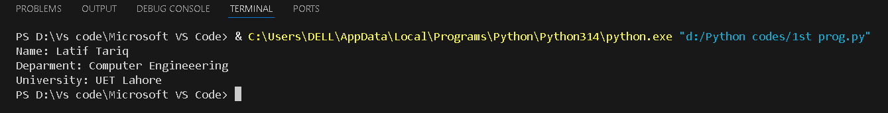

Task No. 2: Using sep and End.

Solution:

print("UET","Lahore","Computer","Engineering",sep="-")

Output:

Task No. 3: Format output.

Solution:

Name: Latif
Age: 19
City: Lahore
print("Name:Latif\nAge:19\nCity:Lahore")

Output:

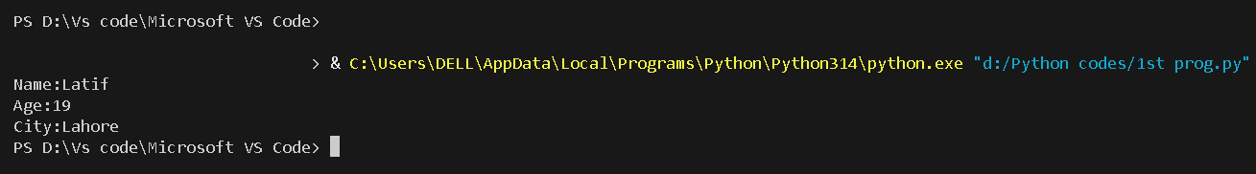

Task no.4: Take name and age.

Solution:

name = input("Enter your name:")
age = int(input("Enter your age:"))
print("Name:",name)
print("Your age:",age)

Output:

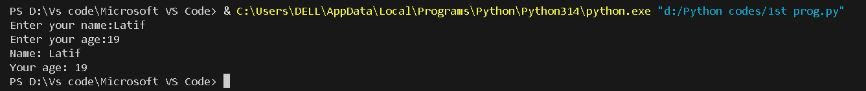

Task no. 5: Identify data types.

Solution:

a = 10
b = 9.8
c = True
name = "UET"
print(a)
print(b)
print(c)

print(type(a))
print(type(b))
print(type(c))

print(len(name))

Output:

